PLASMA DONOR DATABASE MANAGEMENT SYSTEM

FOR COVID-19 PATIENTS

Database for keeping COVID Patients and Plasma Donor Records at hospital and plasma bank respectively

Swathi Badicole |RamyaSree Modadugu |Smita Kulkarni

Table of Contents

DATABASE INITIAL DESIGN 2

OBJECTIVE OF THE DATABASE 2

PROBLEM STATEMENT 2

DESCRIPTION 2

ELIGIBILTY CRITERIA FOR DONORS 3

DATA RETRIEVAL SAMPLES 3

OUT OF SCOPE 3

ASSUMPTIONS 4

DATABASE DESIGN AND MODELING 5

CONCEPTUAL MODEL 5

BUSINESS RULES 5

KEYS 6

TABLE 1.1: 6

PDMS TABLE ATTRIBUTES 7

TABLE 1.2: 7

RELATIONSHIP TABLE 7

TABLE 1.3: 7

CARDINALITY 8

EXISTENCE DEPENDENCY 9

OPTIONAL PARTICIPATION 10

MANDATORY PARTICIPATION 11

WEAK RELATIONSHIPS 11

3NF DEPENDENCY DIAGRAMS 12

ER DIAGRAM 14

DATA DICTIONARIES 15

Table 2.1: 15

Table 2.2: 16

Table 2.3: 16

Table 2.4: 16

Table 2.5: 17

Table 2.6: 17

Table 2.7: 17

Table 2.8: 18

Table 2.9: 20

Table 2.10: 20

Table 2.11: 21

LOGICAL MODEL 22

ENTITY INTEGRITY 22

REFERENTIAL INTEGRITY 22

RELATIONAL SCHEMA 23

TRIGGERS 24

PROCEDURES 25

VIEWS 27

REPORTS 30

DATABASE SECURITY 35

DATA LOAD FILE 36

References: 36

PLASMA DONOR DATABASE MANAGEMENT SYSTEM FOR COVID-19 PATIENTS

# DATABASE INITIAL DESIGN

### OBJECTIVE OF THE DATABASE

This database is aimed at designing and implementing an automated system that will alleviate the problem of handling COVID patients’ data in a hospital and plasma donor information. Our database will felicitate accurate and quick data thereby matching the right plasma donor to the COVID patient. Our proposed database can be used in any hospital or plasma bank that accommodates COVID patients.

### PROBLEM STATEMENT

Under critical conditions, because of poor data management of donors & COVID patients, can lead to unnecessary delays which thereby impacts the patient’s recovery. Lack of Plasma Bank details and donor availability information at hospitals and lack of the recipient details in Plasma bank can be dissatisfactory and lead to patient’s death if plasma is not received on time.

### DESCRIPTION

People who have fully recovered from COVID-19 for at least two weeks are encouraged to consider donating plasma, which may help save the lives of other COVID-19 patients. COVID-19 convalescent plasma (CCP) must only be collected from recovered individuals if they are eligible to donate blood.

Plasma bank works to provide COVID-19 convalescent plasma (CCP) to healthcare institutions that have patients in need.

Hospital offers treatment to the COVID -19 patients and will contact nearest Plasma Bank in need of plasma as part of patient’s treatment.

This database management system felicitates collection and distributing CCP as quickly as possible by efficient database design and modeling. Plasma Banks and Hospitals are our potential stakeholders as this database system will record and store the information of Hospital and Plasma Bank securely thereby matching the right donor to the patient.

### ELIGIBILTY CRITERIA FOR DONORS

* Donors should be 18 years and older and weigh at least 120 lbs.
* Overall good q1health
* Potential donors must have had documented SARS-Cov2 infection or swab positivity
* Donor should be symptom-free for at least 14 days from the donation date
* Should meet standard blood donor eligibility requirements
* Individuals who themselves were treated with plasma for their own Covid-19 illness are not allowed to donate blood samples including plasma for 3 months
* Donations can occur as frequently as weekly for several months following clearance of infection before antibodies begin decreasing.
* Donation frequency varies between different plasma donation centers.

### DATA RETRIEVAL SAMPLES

* Retrieve the number of COVID patients from a particular hospital
* Retrieve the doctor information for each COVID patient
* Retrieve the number of COVID patients transfused with plasma
* Retrieve the details of COVID patient’s city wise that require plasma transfusion
* Retrieve the plasma bank details in a particular state/city
* Retrieve the donor details for each plasma bank
* Retrieve the patient/donor information
* Retrieve the plasma donation details for a particular donor

### OUT OF SCOPE

* If Donor visits any nearby hospital to donate plasma directly instead of donating in Plasma Bank, then the donor records will not be stored in our PDMS as we receive the Donor data from Plasma Bank records.
* One plasma donation utilized for multiple patients. PDMS assumes that each plasma donation will be utilized for one patient or one Plasma transfusion and the corresponding Plasma availability is nullified after the transfusion.
* Our database maintains the Billing records for plasma transfusion for the COVID patient. Any other Billing records related to COVID patients are directly maintained by Hospitals.
* Non COVID patient’s data is not maintained in PDMS. It currently falls under future PDMS expansion scope.

### ASSUMPTIONS

* Once the patient is transfused with plasma, he is not eligible for another transfusion.
* Each hospital will have at least one doctor
* Each hospital will have at least one room
* Each plasma donation will be used for one plasma transfusion

# DATABASE DESIGN AND MODELING

## CONCEPTUAL MODEL

### BUSINESS RULES

Following are the Business Rules documented for our Project:

1. One COVID patient belongs to one hospital.
2. One hospital can have many COVID patients.
3. Each patient will have one blood group
4. Multiple patients will have the same blood group.
5. Each doctor belongs to one hospital.
6. One hospital can have multiple doctors.
7. Each patient can get treatment from one doctor.
8. Each doctor can treat multiple patients.
9. Each hospital has many rooms.
10. Each room belongs to one hospital.
11. Each COVID patient is admitted to one room.
12. Each room can admit one patient at a time.
13. One COVID patient can have many billings.
14. Each billing belongs to one patient.
15. Each patient can receive one plasma transfusion
16. Plasma transfusion can be done for multiple patients
17. Each Plasma transfusion can have multiple Billing
18. Each Billing is related to one plasma transfusion
19. Each donor can do the plasma donation multiple times
20. Each donation is done by one donor at a time
21. Each donor will have one blood group
22. Multiple patients will have the same blood group.
23. One donor can donate in many Plasma banks.
24. Each Plasma Bank can receive plasma from many donors
25. Each donation is related to one plasma bank.

### KEYS

Following are the Entities and Keys identified for PDMS:

#### TABLE 1.1:

|  |  |  |
| --- | --- | --- |
| ENTITY | PRIMARY KEY | FOREIGN KEY |
| HOSPITAL | HOSPITAL_ID | NA |
| DOCTOR | DOCTOR_ID | HOSPITAL_ID |
| ROOM | ROOM_ID | HOSPITAL_ID |
| PATIENT | PATIENT_ID | HOSPITAL_ID, DOCTOR_ID, ROOM_ID, BLOOD_GROUP_ID |
| PLASMA_BANK | PBANK_ID | NA |
| BILLING | BILLING_ID | PATIENT_ID, PLASMA_TRANS_ID |
| PLASMA_TRANSFUSION | PLASMA_TRANS_ID | PATIENT_ID, DONATION_ID, P_AVAIL_ID |
| DONOR | DONOR_ID | PBANK_ID, BLOOD_GROUP_ID |
| DONATION | DONATION_ID | DONOR_ID, PBANK_ID |
| BLOOD_GROUP | BLOOD_GROUP_ID | NA |
| PLASMA_AVAILABILITY | P_AVAIL_ID | DONATION_ID, PBANK_ID |

### PDMS TABLE ATTRIBUTES

Following are the TABLE Attributes identified for PDMS:

#### TABLE 1.2:

### RELATIONSHIP TABLE

Relationship between all of the entities is shown in the following table:

#### TABLE 1.3:

|  |  |  |  |
| --- | --- | --- | --- |
| ENTITY | RELATIONSHIP | CONNECTIVITY | ENTITY |
| HOSPITAL | admits | 1:M | PATIENT |
| HOSPITAL | has | 1:M | ROOM |
| HOSPITAL | employs | 1:M | DOCTOR |
| PATIENT | pays | 1:M | BILLING |
| PATIENT | receives | 1:1 | PLASMA_TRANS |
| PLASMA_AVAILABILITY | is used for | 1:1 | PLASMA_TRANS |
| DONOR | donates | 1:M | DONATION |
| DONOR | belongs to | 1:1 | BLOOD GROUP |
| PATIENT | belongs to | 1:1 | BLOOD GROUP |
| PATIENT | is admitted to | 1:1 | ROOM |
| PATIENT | treated by | 1:1 | DOCTOR |
| BILLING | includes | 1:1 | PLASMA_TRANS |
| DOCTOR | treats | 1:M | PATIENT |
| DONATION | received by | 1:1 | DONOR |
| PATIENT | admitted to | 1:1 | HOSPITAL |
| BLOOD GROUP | includes | 1:M | PATIENT |
| BLOOD GROUP | includes | 1:M | DONOR |
| PLASMA_BANK | has | 1:M | PLASMA_AVAILABILITY |
| DONATION | has | 1:1 | PLASMA_AVAILABILITY |
| PLASMA_BANK | has | 1:M | DONATION |
| PLASMA_TRANSFUSION | received by | 1:M | PATIENT |

### CARDINALITY

Cardinality can be defined as a property that assigns a specific value to connectivity and expresses the range of allowed entity occurrences associated with a single occurrence of the related entity.

In the ERD, cardinality is indicated by placing the appropriate numbers beside the entities, using the format (x,y). The first value represents the minimum number of associated entities, while the second value represents the maximum number of associated entities.

* A hospital may have zero or more than one PATIENT and cardinality value is (0,N), while each PATIENT is related to one HOSPITAL, so the cardinality value is (1,1)
* A hospital may have one or more than one ROOM and cardinality value is (1,N), while each ROOM is related to one HOSPITAL, so the cardinality value is (0,1)
* A hospital may have one or more than one DOCTOR and cardinality value is (1,N), while each DOCTOR is related to one HOSPITAL, so the cardinality value is (1,1)
* A patient may have zero or more than one BILLING and cardinality value is (0, N), while each BILLING is related to one PATIENT, so the cardinality value is (1,1)
* A patient may have zero or one PLASMA_TRANS and cardinality value is (0,1), while PLASMA_TRANS is related to zero or more PATIENT, so the cardinality value is (0,N).
* A Donor may have one or more than one DONATION and cardinality value is (1, N), while each DONATION is related to one DONOR, so the cardinality value is (1,1)
* A Donor can have one BLOOD_GROUP and cardinality value is (1,1), while each BLOOD_GROUP is related to zero or more than one DONOR, so the cardinality value is (0, N)
* A PATIENT can have one BLOOD_GROUP and cardinality value is (1,1), while each BLOOD_GROUP is related to zero or more than one PATIENT, so the cardinality value is (0, N)
* A patient may be in one ROOM and cardinality value is (1,1), while each ROOM is related to one PATIENT at a time, so the cardinality value is (1,1)
* A patient may be treated by one DOCTOR and cardinality value is (1,1), while each DOCTOR is related to zero or many PATIENTS, so the cardinality value is (0, N)
* A Billing may be for one PLASMA_TRANS and cardinality value is (1,1), while each PLASMA_TRANS may have one BILLING, so the cardinality value is (1, N).
* A Plasma_availability for one Donation and Cardinality value is (1,1), While Each Donation can result in one Plasma_availability and Cardinality is (1,1).
* A Plasma_Bank can have zero or more Plasma_availability and Cardinality is (0,N),

While each plasma_availability is one Plasma_Bank and cardinality is (1,1).

* A Plasma_transfusion can be one or more Plasma_availability and Cardinality is (1,N),

While each plasma_availability can be zero or more Plasma_transfusion and cardinality are (0,N).

* A Patient can have zero or more Billing and cardinality value is (0,N), while each Billing is related to one Patient, so the cardinality value is (1,1).

### EXISTENCE DEPENDENCY

An entity is said to be existence-dependent if it can exist in the database only when it is associated with another related entity occurrence. In implementation terms, an entity is existence-dependent if it has a mandatory foreign key—that is, a foreign key attribute that cannot be null.

Following is identified as existence-dependent in our database model:

* In case of DONATION and DONOR entity, a DONATION entity cannot exist independently from DONOR entity as a donation can happen only if a donor is available. In this scenario, DONATION existence is dependent on a DONOR entity. The foreign key attribute Donor_id cannot be null in DONATION table.

Following is identified as existence-independent in our database model:

* If an entity can exist apart from all of its related entities, then it is existence-independent, and it is referred to as a strong entity or regular entity. For Example:  In case of HOSPITAL and PLASMA_BANK, both entities can continue to exist independently without being dependent on each other.

### OPTIONAL PARTICIPATION

One entity occurrence does not require a corresponding entity occurrence in a particular relationship.

1. Hospital to Patient
2. Patient to Billing
3. Patient to Plasma_trans
4. Donation to Plasma_trans
5. Plasma_bank to Donation
6. Donor to Blood_group
7. Patient to Blood_group
8. Doctor to Patient
9. Plasma_bank to Plasma_availability
10. Plasma_bank  to Donation
11. Blood_group to Donor
12. Plasma_Transfusion to Patient
13. Patient to Plasma_Transfusion
14. Room to Patient
15. Blood_group to Patient

### MANDATORY PARTICIPATION

One entity occurrence does require a corresponding entity occurrence in a particular relationship.

1. Plasma_Transfusion to Plasma_availability
2. Donor to Donation
3. Plasma_availability to Donation
4. Plasma_Transfusion to Billing
5. Hospital to Room
6. Hospital to Doctor
7. Patient to Doctor
8. Patient to Hospital
9. Patient to Room
10. Patient to Blood_group
11. Billing to Patient
12. Plasma_availability to Plasma_bank
13. Donation to Plasma_Bank

### WEAK RELATIONSHIPS

Following are identified as weak relationship in our database model as each entity has its own primary key and it is not derived from the parent’s primary key.

1. Patient and Hospital
2. Hospital and Doctor
3. Hospital and Room
4. Patient and Billing
5. Billing & Plasma_Transfusion
6. Patient and Plasma_Transfusion
7. Donation & Donor
8. Patient & Blood_group
9. Donor & Blood_group
10. Plasma_availability & Plasma_Bank
11. Plasma_availability & Donation

### 3NF DEPENDENCY DIAGRAMS











### ER DIAGRAM

Following is the Entity Relationship Diagram for PDMS:

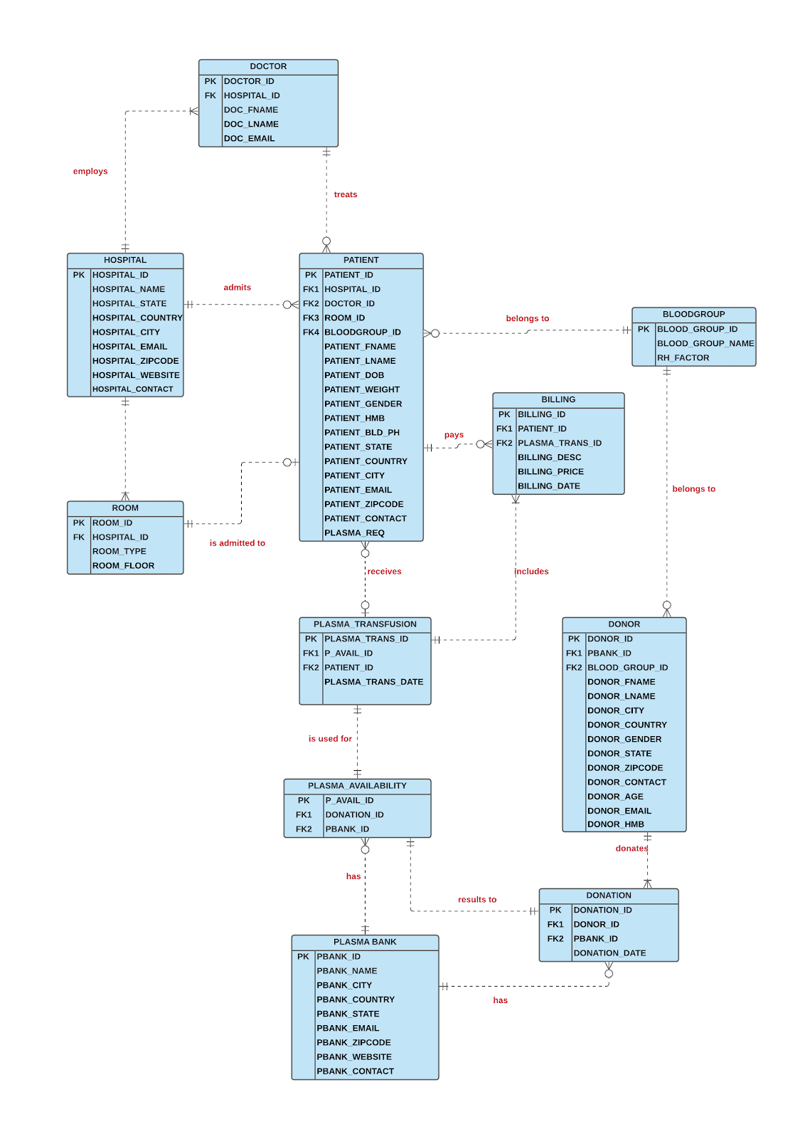

### DATA DICTIONARIES

#### Table 2.1:

BLOOD GROUP TABLE: Contains Blood group Information.

|  |  |  |  |
| --- | --- | --- | --- |
| COLUMN | TYPE | DESCRIPTION | EXAMPLE |
| Blood_Grp_ID(PK) | INT | Unique ID to identify blood groups | 1 |
| Blood_Grp_Name | VARCHAR(3) | To know the blood group name | O+ |

#### Table 2.2:

DOCTOR TABLE: Contains Information about Each doctor.

|  |  |  |  |
| --- | --- | --- | --- |
| COLUMN | TYPE | DESCRIPTION | EXAMPLE |
| DOC_ID(PK) | INT | UNIQUE ID TO IDENTIFY DOCTORS | 10001 |
| DOC_FNAME | VARCHAR(15) | FIRST NAME OF DOCTORS | STEPHEN |
| DOC_LNAME | VARCHAR(15) | LAST NAME OF DOCTORS | HARRIS |
| DOC_EMAIL | VARCHAR(35) | EMAIL ID OF DOCTORS | [stephen.harris@gmail.com](mailto:stephen.harris@gmail.com) |
| HOSPITAL_ID(FK) | INT | FOREIGN KEY ID WHICH REFERS HOSPITAL TABLE | 101 |

#### Table 2.3:

DONATION TABLE: Contains Information about Donation.

|  |  |  |  |
| --- | --- | --- | --- |
| COLUMN | TYPE | DESCRIPTION | EXAMPLE |
| DONATION_ID(PK) | VARCHAR(5) | Unique ID to identify all the donations. | D1 |
| DONATION_DATE | DATE | To know on which date donor donated. | 9/12/2020 |
| PBANK_ID(FK) | INT | Foreign key refers to the pk in  plasma Bank table. | 1009 |
| DONOR_ID(FK) | INT | Foreign key refers to the pk in  donor table to know who donated | 5001 |

#### Table 2.4:

PLASMA_AVAILABILITY TABLE: Contains Information if plasma is available.

|  |  |  |  |
| --- | --- | --- | --- |
| COLUMN | TYPE | DESCRIPTION | EXAMPLE |
| P_AVAIL_ID(PK) | INT | Unique ID to identify available plasma in plasma banks. | 1 |
| PBANK_ID(FK) | INT | FK refers to PK in plasma bank table | 10/10/1902 |
| DONATION_ID(FK) | INT | FK refers to PK in donation table | D2 |
| P_AVAIL_STATUS | VARCHAR(5) | To know the status of the plasma availability. | N/Y |

#### Table 2.5:

PLASMA_BANK TABLE: Contains detail about all plasma banks.

|  |  |  |  |
| --- | --- | --- | --- |
| COLUMN | TYPE | DESCRIPTION | EXAMPLE |
| PBANK_ID (PK) | INT | Unique attribute to identify all plasma banks. | 1012 |
| PBANK_NAME | VARCHAR(100) | It has Names of the plasma banks. | Bloodworks Silvered |
| PBANK_EMAIL | VARCHAR(35) | Email address of the plasma banks. | [silverdalerdonor@yahoo.com](mailto:silverdalerdonor@yahoo.com) |
| PBANK_STATE | VARCHAR(20) | To know in which state this plasma bank exists. | CA |
| PBANK_COUNTRY | VARCHAR(15) | To know in which country this plasma bank exists. | USA |
| PBANK_CITY | VARCHAR(20) | To know in which city this plasma bank exists. | San Jose |
| PBANK_ZIPCODE | CHAR(5) | Zip code of plasma bank location. | 95035 |
| PBANK_CONTACT | VARCHAR(15) | Contact number of plasma bank incase if donor needs. | 360-308-7340 |
| PBANK_WEBSITE | VARCHAR(255) | Website to book online or to know their details. | [https://www.bloodworksnw.org](https://www.bloodworksnw.org/) |

#### Table 2.6:

PLASMA TRANSFUSION TABLE: Contains Information about Plasma Transfusion.

|  |  |  |  |
| --- | --- | --- | --- |
| COLUMN | TYPE | DESCRIPTION | EXAMPLE |
| PLASMA_TRANS_ID(PK) | INT | Unique attribute which is to identify the table. | 2001 |
| PLASMA_TRANS_DATE | DATETIME | Stores the date when plasma transfused to patient. | 11/8/2020 |
| PATIENT_ID(FK) | INT | Foreign key referencing patient table. | 12 |
| P_AVAIL_ID(FK) | INT | Foreign Key referencing plasma_availability table. | 15 |

#### Table 2.7:

HOSPITAL TABLE: Contains detail of Hospitals.

|  |  |  |  |
| --- | --- | --- | --- |
| COLUMN | TYPE | DESCRIPTION | EXAMPLE |
| HOSPITAL_ID(PK) | INT | Unique Key that identifies all hospitals. | 115 |
| HOSPITAL_NAME | VARCHAR(35) | Name of the Hospital. | Stanford |
| HOSPITAL_EMAIL | VARCHAR(35) | Email ID of the Hospital. | [standfordhealth@gmail.com](mailto:standfordhealth@gmail.com) |
| HOSPITAL_CITY | VARCHAR(15) | City Where Hospital is located. | Milpitas |
| HOSPITAL_STATE | VARCHAR(15) | State of the Hospital. | WA |
| HOSPITAL_COUNTRY | VARCHAR(15) | Country where hospital is. | USA |
| HOSPITAL_ZIPCODE | CHAR(5) | Zip code of hospital location. | 94025 |
| HOSPITAL_CONTACT | VARCHAR(15) | Contact number of Hospital. | 234-456-3000 |
| HOSPITAL_WEBSITE | VARCHAR(255) | Website of Hospital | [https://www.stanford.org](https://www.stanford.org/) |

#### Table 2.8:

DONOR TABLE: Contains information about each donor.

|  |  |  |  |
| --- | --- | --- | --- |
| COLUMN | TYPE | DESCRIPTION | EXAMPLE |
| DONOR_ID(PK) | INT | Unique key which identifies all donors. | 5001 |
| DONOR_FNAME | VARCHAR(15) | First Name of the Donor. | Dave |
| DONOR_LNAME | VARCHAR(15) | Last Name of the Donor. | Gin |
| DONOR_EMAIL | VARCHAR(35) | Stores Email ID of donors. | [dave_gin23@gmail.com](mailto:dave_gin23@gmail.com) |
| DONOR_AGE | INT | Stores Age of donors. | 23 |
| DONOR_GENDER | CHAR(1) | To know gender of donors. | F/M |
| DONOR_CITY | VARCHAR(20) | Stores the city Name where donor belongs to. | San Jose |
| DONOR_STATE | VARCHAR(20) | State of the donors. | CA |
| DONOR_COUNTRY | VARCHAR(15) | Country of the donors. | USA |
| DONOR_ZIPCODE | CHAR(5) | Zip code of donors’ locations. | 980412 |
| DONOR_CONTACT | VARCHAR(15) | Contact number of all donors. | 380-234-5000 |
| PBANK_ID(FK) | INT | Foreign key referencing plasma bank. | 1001 |
| BLD_GRP_ID(FK) | INT | Foreign key referencing to blood group table. | 5 |
| DONOR_HMB | DECIMAL(9,1) | Stores HMB values of donors. | 15.1 |

#### Table 2.9:

BILLING TABLE: Contains Information about patients’ billings.

|  |  |  |  |
| --- | --- | --- | --- |
| COLUMN | TYPE | DESCRIPTION | EXAMPLE |
| BILLING_ID | INT | Unique Key which identifies all billings. | 30001 |
| BILLING_PRICE | DECIMAL(9,2) | Price of the patient bill. | 3/18/1908 |
| BILLING_DESC | VARCHAR(35) | Type of treatment. | Plasma Transfusion |
| BILLING_DATE | DATETIME | Billing date of patient’s treatment. | 9/20/2020 |
| PLASMA_TRANS_ID(FK) | INT | Foreign key referencing to transfusion table. | 2001 |
| PATIENT_ID(FK) | INT | Foreign Key referencing to patient table. | 1 |

#### Table 2.10:

PATIENT TABLE: Contains Information about Patients.

|  |  |  |  |
| --- | --- | --- | --- |
| COLUMN | TYPE | DESCRIPTION | EXAMPLE |
| PATIENT_ID(PK) | INT | Unique ID which identifies all patients. | 1 |
| PATIENT_FNAME | VARCHAR(15) | Patients First Name. | Jhon |
| PATIENT_LNAME | VARCHAR(15) | Patients Last Name. | Mishra |
| PATIENT_DOB | DATE | Patients Date of birth. | 9/3/1986 |
| PATIENT_GENDER | CHAR(1) | Gender of patients. | F/M |
| PATIENT_WEIGHT | DECIMAL(9,2) | stores weight. | 156.05 |
| PATIENT_HMB | DECIMAL(9,1) | HMB level of patients. | 13.1 |
| PATIENT_BLD_PH | DECIMAL(9,1) | Blood ph level. | 7.2 |
| PLASMA_REQ | CHAR(1) | If plasms required or not. | Y/N |
| PATIENT_EMAIL | VARCHAR(35) | Email ID of patients. | [jhonmishra@gmail.com](mailto:jhonmishra@gmail.com) |
| PATIENT_CITY | VARCHAR(20) | City where he/she is located. | Fremont |
| PATIENT_STATE | VARCHAR(20) | state of the patient. | CA |
| PATIENT_COUNTRY | VARCHAR(15) | Which country they belong to. | USA |
| PATIENT_ZIPCODE | CHAR(5) | Zip Code of their area. | 95035 |
| PATIENT_CONTACT | VARCHAR(15) | contact number. | 669-765-2000 |
| BLD_GRP_ID(FK) | INT | Foreign key referencing blood group table. | 4 |
| ROOM_ID(FK) | VARCHAR(10) | Foreign Key referencing room table. | G10 |
| HOSPITAL_ID(FK) | INT | Foreign Key referencing Hospital Table. | 101 |
| DOC_ID(FK) | INT | Foreign Key referencing Doctor table. | 10012 |

#### Table 2.11:

ROOM TABLE: Contains Information about rooms to which patients are admitted

|  |  |  |  |
| --- | --- | --- | --- |
| COLUMN | TYPE | DESCRIPTION | EXAMPLE |
| ROOM_ID(PK) | VARCHAR(5) | Unique Key to identify rooms. | A10 |
| ROOM_TYPE | VARCHAR(15) | Type of Hospital room. | ICU/GENERAL |
| ROOM_FLOOR | INT | Which floor the room is in. | 1 |
| HOSPITAL_ID(FK) | INT | Foreign key referencing to Hospital Table. | 4/12/1900 |

## LOGICAL MODEL

### ENTITY INTEGRITY

Following tables exhibit Entity Integrity as each of these table have primary keys and cannot have NULL entries

|  |
| --- |
| HOSPITAL |
| PATIENT |
| DOCTOR |
| ROOM |
| BLOOD_GROUP |
| BILLING |
| PLASMA_TRANSFUSION |
| PLASMA_AVAILABILITY |
| PLASMA_BANK |
| DONOR |
| DONATION |

### REFERENTIAL INTEGRITY

Following tables exhibit Referential Integrity as each of these tables has foreign keys that links the corresponding table to another table.

|  |
| --- |
| PATIENT |
| DOCTOR |
| ROOM |
| BILLING |
| PLASMA_TRANSFUSION |
| PLASMA_AVAILABILITY |
| DONOR |
| DONATION |

### RELATIONAL SCHEMA

Following is the relational schema that will be used for PDMS:

HOSPITAL(Hospital_id, Hospital_name, Hospital_email, Hospital_State, Hospital_Country,Hospital_City ,Hospital_ZipCode, Hospital_contact, Hospital_website)

PATIENT(Patient_id, Patient_Fname, Patient_Lname, Patient_DOB, Patient_Gender, Weight, Blood_group_id, Patient_Hmb, Patient_Bld_ph, Patient_State, Patient_City, Patient_Country, Patient_Zipcode, Patient_contact, email, Room_id, Hospital_id, Doctor_id, Plasma_Req)

PLASMA_BANK(Pbank_id, Pbank_name, Pbank_email, Pbank _State, Pbank _Country , Pbank _City , Pbank_ZipCode, Pbank_contact, Pbank_website,donation_id)

PLASMA_TRANSFUSION(Plasma_Trans_Id, P_avail_id, Patient_id, plasma_transfusion_date)

DONOR(Donor_id, Donor_name, Donor_email, Donor_State, Donor _City, Donor_Country, Donor_Zipcode, Donor_contact, Donor_Gender, Donor_Age, Bank_id, Blood_group_id)

DONATION(Donation_id, Donation_date, Donor_id, PBank_id)

BILLING( Billing_id, billing_price, Billing_Desc, Billing_Date, Plasma_trans_id, Patient_id)

ROOM(Room_id, Floor, Room_type , Hospital_id)

DOCTOR(Doctor_id, Doc_fname, Doc_lname, Doc_email, Hospital_id)

BLOOD_GROUP(Blood_Group_Id, Blood_group_Name)

PLASMA_AVAILABILITY(P_Avail_ID, Pbank_ID, Donation_ID, Plasma_Avail)

### TRIGGERS

Following are the triggers we have identified that will be required for PDMS:

* Trigger Name: PATIENT_PLASMA_REQ
  + Patient’s table Plasma_Req attribute needs to be changed to ‘N’ soon after the Patient receives plasma transfusion. This will ensure the same patient is not considered for next plasma transfusion.

Query:

DROP TRIGGER IF EXISTS `pdms`.`PATIENT_PLASMA_REQ`;

DELIMITER $$

USE `pdms`$$

CREATE DEFINER = CURRENT_USER TRIGGER `pdms`.`PATIENT_PLASMA_REQ`

AFTER INSERT ON `PLASMA_TRANSFUSION` FOR EACH ROW

BEGIN

UPDATE PATIENT

SET PLASMA_REQ= 'N'

WHERE PATIENT_ID=NEW.PATIENT_ID;

END$$

DELIMITER ;

* Trigger Name: DONATION_AFTER_INSERT
  + An Entry in the Donation table needs to make a corresponding entry in Plasma_Availability table. This is required as each plasma donation is made available for patients' needs.

DROP TRIGGER IF EXISTS `pdms`.`DONATION_AFTER_INSERT`;

DELIMITER $$

USE `pdms`$$

CREATE DEFINER = CURRENT_USER TRIGGER `pdms`.`DONATION_AFTER_INSERT` AFTER INSERT ON `DONATION` FOR EACH ROW

BEGIN

INSERT INTO PLASMA_AVAILABILITY (PBANK_ID,DONATION_ID,P_AVAIL_STATUS) VALUES (NEW.PBANK_ID, NEW.DONATION_ID,'Y');

END$$

DELIMITER ;

* Trigger Name: PLASMA_TRANSFUSION_AFTER_INSERT
  + When a patient receives plasma, the corresponding record from Plasma_Availability table will be deleted. This is required as once the plasma donation is used for plasma transfusion it cannot be used again for another patient.

DROP TRIGGER IF EXISTS `pdms`.`PLASMA_TRANSFUSION_AFTER_INSERT`;

DELIMITER $$

USE `pdms`$$

CREATE DEFINER = CURRENT_USER TRIGGER `pdms`.`PLASMA_TRANSFUSION_AFTER_INSERT` AFTER INSERT ON `PLASMA_TRANSFUSION` FOR EACH ROW

BEGIN

UPDATE PLASMA_AVAILABILITY

SET P_AVAIL_STATUS='N'

WHERE P_AVAIL_ID= NEW.P_AVAIL_ID;

END$$

DELIMITER ;

### PROCEDURES

Following are the procedures we have identified that will be required for PDMS:

* Procedure Name: get_nearby_plasma_banks
  + To find the plasma banks available in nearby proximity from the patient city by passing the patient city as input parameter.

DROP PROCEDURE IF EXISTS get_nearby_plasma_banks;

DELIMITER $$

CREATE PROCEDURE get_nearby_plasma_banks(

IN PAT_CITY VARCHAR(50)

)

BEGIN

SELECT PLASMA_BANK.PBANK_ID, PBANK_NAME, PBANK_CITY, PBANK_ZIPCODE, BLD_GROUP_NAME, count(BLD_GROUP_NAME) AS COUNT

FROM PLASMA_BANK JOIN PLASMA_AVAILABILITY

ON PLASMA_BANK.PBANK_ID = PLASMA_AVAILABILITY.PBANK_ID

JOIN DONATION

ON DONATION.DONATION_ID = PLASMA_AVAILABILITY.DONATION_ID

JOIN DONOR

ON DONOR.DONOR_ID = DONATION.DONOR_ID

JOIN BLOOD_GROUP

ON DONOR.BLD_GRP_ID = BLOOD_GROUP.BLD_GRP_ID

WHERE P_AVAIL_STATUS = 'Y' AND PBANK_CITY = PAT_CITY

GROUP BY PLASMA_AVAILABILITY.PBANK_ID,DONOR.BLD_GRP_ID;

END $$

DELIMITER ;

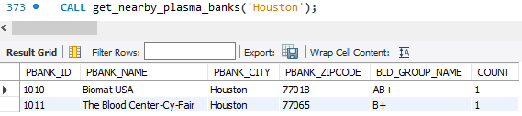

* Procedure Name: find_plasma_match
  + To check for the blood group matching plasma’s, by retrieving the patient blood_group and comparing against all the plasma donors and getting their respective donation status if it is available by passing the patient_id as input parameter.

DROP PROCEDURE find_plasma_match;

DELIMITER $$

CREATE PROCEDURE find_plasma_match(

IN PAT_ID INT

)

BEGIN

SELECT PATIENT_ID, PATIENT_LNAME, PATIENT_CITY, BLD_GROUP_NAME AS PATIENT_BLD_GRP, PB.PBANK_NAME,DONATION.PBANK_ID,DONOR.DONOR_ID,PBANK_CONTACT,PBANK_CITY,

DONOR_LNAME, BLD_GROUP_NAME AS DONOR_BLD_GRP, DONATION.DONATION_ID, P_AVAIL_STATUS

FROM PATIENT JOIN BLOOD_GROUP

ON PATIENT.BLD_GRP_ID = BLOOD_GROUP.BLD_GRP_ID

JOIN DONOR

ON BLOOD_GROUP.BLD_GRP_ID = DONOR.BLD_GRP_ID

JOIN DONATION

ON DONOR.DONOR_ID = DONATION.DONOR_ID

JOIN PLASMA_AVAILABILITY PA

ON DONATION.DONATION_ID = PA.DONATION_ID

JOIN PLASMA_BANK PB

ON PB.PBANK_ID=PA.PBANK_ID

WHERE P_AVAIL_STATUS = 'Y'

AND PATIENT.BLD_GRP_ID = DONOR.BLD_GRP_ID

AND PATIENT_ID = PAT_ID

AND PATIENT_CITY=PBANK_CITY;

END $$

DELIMITER ;

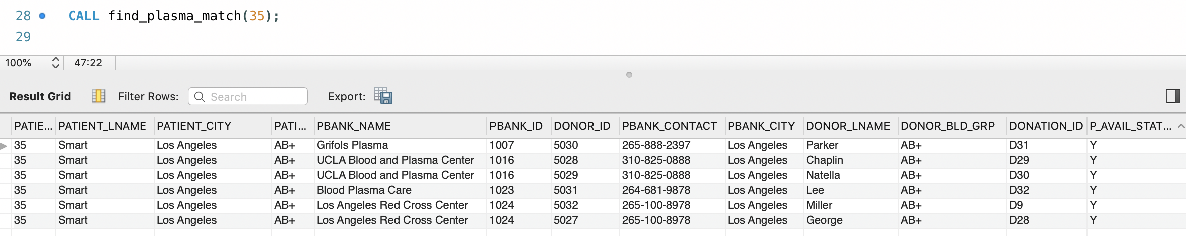

* Procedure Name: get_overall_patient_details
  + Complete patient-related details like name, contact, plasma-transfusion, and corresponding plasma_bank details can be fetched by, passing patient_id, which can be used while billing or to access them easily.

DROP PROCEDURE get_overall_patient_details;

DELIMITER $$

CREATE PROCEDURE get_overall_patient_details(

IN PAT_ID INT

)

BEGIN

SELECT PATIENT.PATIENT_ID, CONCAT(PATIENT_FNAME, PATIENT_LNAME) AS FULL_NAME, PATIENT_CONTACT, HOSPITAL_ID PLASMA_TRANS_ID,

PBANK_ID, DATE(PLASMA_TRANS_DATE) AS TRANS_DATE, ROOM_ID, BILLING_PRICE, BILL_PAID

FROM PATIENT JOIN PLASMA_TRANSFUSION

ON PATIENT.PATIENT_ID = PLASMA_TRANSFUSION.PATIENT_ID

JOIN PLASMA_AVAILABILITY

ON PLASMA_TRANSFUSION.P_AVAIL_ID = PLASMA_AVAILABILITY.P_AVAIL_ID

JOIN BILLING B

ON PATIENT.PATIENT_ID = B.PATIENT_ID

WHERE PATIENT.PATIENT_ID = PAT_ID;

END $$

DELIMITER ;

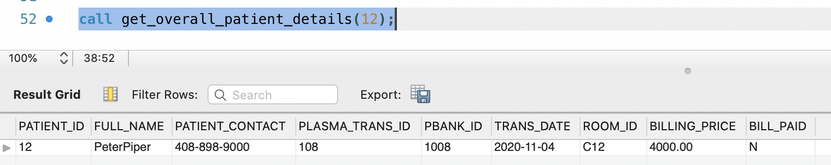

SUMMARY:

Following are the stored procedures we created in our pdms using real-time scenarios.

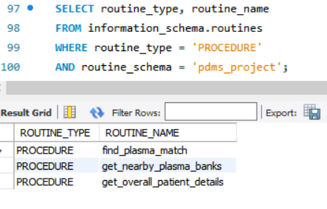

### VIEWS

Following are the views we have identified that will be required for PDMS:

* View Name: PATIENTS_PER_CITY
  + Provides the number of patients getting admitted in each city that require plasma, this would be helpful to identify highly affected cities.

CREATE VIEW PATIENTS_PER_CITY AS

SELECT PATIENT_CITY, COUNT(patient_id) AS NO_OF_PATIENTS, PLASMA_REQ

FROM PATIENT

WHERE PLASMA_REQ = 'Y'

group by PATIENT_CITY

ORDER BY NO_OF_PATIENTS DESC;

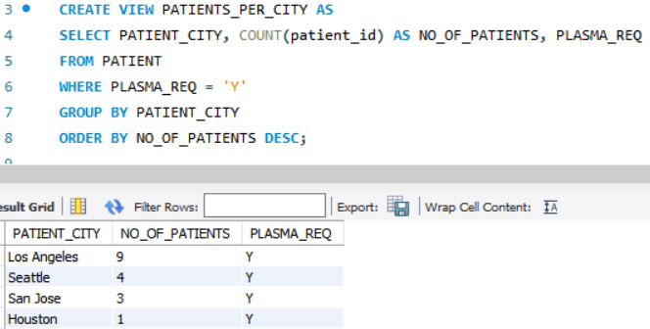

* View Name: LA_AVAILABLE_PLASMAS
  + LA_Available_plasmas view will be helpful to check the availability of the number of plasma’s that are available for transfusion immediately, as Los Angeles has a greater number of patients as per current data.

CREATE VIEW LA_AVAILABLE_PLASMAS AS

SELECT PLASMA_BANK.PBANK_ID, PBANK_NAME, PBANK_CONTACT, PBANK_CITY, PBANK_ZIPCODE,

BLD_GROUP_NAME, count(BLD_GROUP_NAME) AS COUNT, P_AVAIL_STATUS

FROM BLOOD_GROUP JOIN DONOR

ON BLOOD_GROUP.BLD_GRP_ID = DONOR.BLD_GRP_ID

JOIN DONATION

ON DONOR.DONOR_ID = DONATION.DONOR_ID

JOIN PLASMA_AVAILABILITY

ON DONATION.DONATION_ID = PLASMA_AVAILABILITY.DONATION_ID

JOIN plasma_bank

ON DONATION.PBANK_ID = PLASMA_BANK.PBANK_ID

WHERE P_AVAIL_STATUS = 'Y'

AND PBANK_CITY = 'Los Angeles'

GROUP BY PBANK_CITY,BLD_GROUP_NAME

ORDER BY PLASMA_BANK.PBANK_ID;

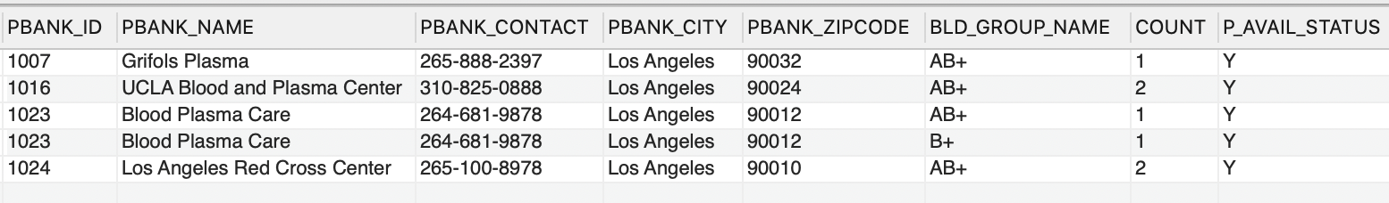

* View Name: NO_OF_TRANSFUSIONS
  + View will be helpful to get the overview of transfusions that happened with each plasma bank with respective transfusion dates.

CREATE VIEW NO_OF_TRANSFUSIONS AS

SELECT DATE(PLASMA_TRANS_DATE) AS DATE, PBANK_ID, COUNT(PLASMA_TRANS_ID) AS COUNT_PER_BANK

FROM PLASMA_TRANSFUSION JOIN PLASMA_AVAILABILITY

ON PLASMA_TRANSFUSION.P_AVAIL_ID = PLASMA_AVAILABILITY.P_AVAIL_ID

GROUP BY PLASMA_TRANS_DATE, PBANK_ID;

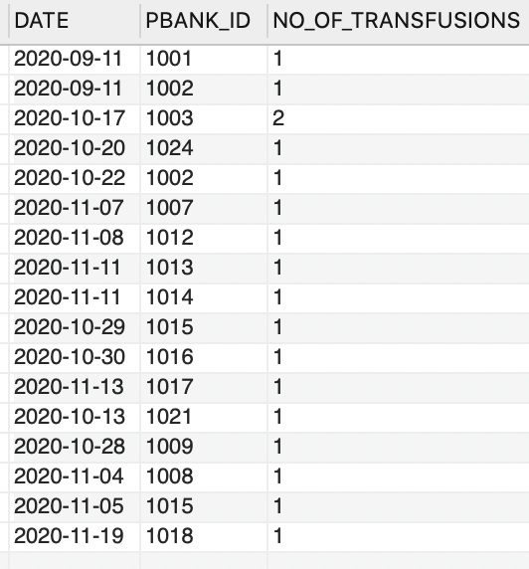

SUMMARY:

Non-Updatable Views:

Our project views are not updatable as they have aggregate functions, group by function, and joins.

SELECT table_name, is_updatable, table_schema

FROM information_schema.views

WHERE table_schema = 'pdms_project'

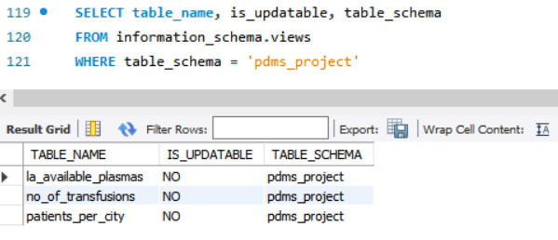

### REPORTS

Patient Count Based on Gender:

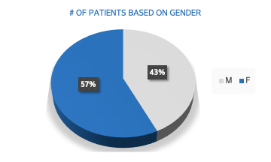

SELECT PATIENT_GENDER, COUNT(PATIENT_GENDER)

FROM PATIENT

GROUP BY PATIENT_GENDER;

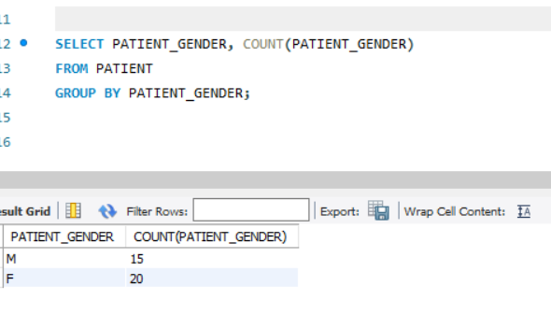

Patient Count Based On AGE:

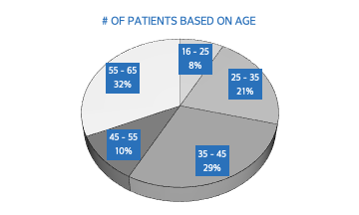

SELECT '16 - 25' AS AGE, COUNT(ROUND(DATEDIFF(CURRENT_DATE(), PATIENT_DOB) / 365.25)) AS COUNT

FROM PATIENT

WHERE ROUND(DATEDIFF(CURRENT_DATE(), PATIENT_DOB) / 365.25) BETWEEN 16 AND 25

UNION

SELECT '25 - 35' AS AGE, COUNT(ROUND(DATEDIFF(CURRENT_DATE(), PATIENT_DOB) / 365.25)) AS COUNT

FROM PATIENT

WHERE ROUND(DATEDIFF(CURRENT_DATE(), PATIENT_DOB) / 365.25) BETWEEN 25 AND 35

UNION

SELECT '35 - 45' AS AGE, COUNT(ROUND(DATEDIFF(CURRENT_DATE(), PATIENT_DOB) / 365.25)) AS COUNT

FROM PATIENT

WHERE ROUND(DATEDIFF(CURRENT_DATE(), PATIENT_DOB) / 365.25) BETWEEN 35 AND 45

UNION

SELECT '45 - 55' AS AGE, COUNT(ROUND(DATEDIFF(CURRENT_DATE(), PATIENT_DOB) / 365.25)) AS COUNT

FROM PATIENT

WHERE ROUND(DATEDIFF(CURRENT_DATE(), PATIENT_DOB) / 365.25) BETWEEN 45 AND 55

UNION

SELECT '55 - 65' AS AGE, COUNT(ROUND(DATEDIFF(CURRENT_DATE(), PATIENT_DOB) / 365.25)) AS COUNT

FROM PATIENT

WHERE ROUND(DATEDIFF(CURRENT_DATE(), PATIENT_DOB) / 365.25) BETWEEN 55 AND 65;

Donations between Age groups 18-25, 26-29, 30-35, 35-40 :

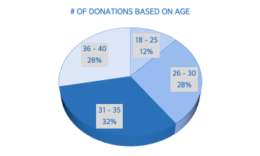

SELECT '18 - 25' as AGE, COUNT(DONOR_AGE) AS DONATIONS_PER_AGE_GROUP

FROM DONOR

WHERE DONOR_AGE BETWEEN 18 AND 25

UNION ALL

SELECT '26 - 30' AS AGE, COUNT(DONOR_AGE) AS DONATIONS_PER_AGE_GROUP

FROM DONOR

WHERE DONOR_AGE BETWEEN 26 AND 30

UNION ALL

SELECT '31 - 35' AS AGE, COUNT(DONOR_AGE) AS DONATIONS_PER_AGE_GROUP

FROM DONOR

WHERE DONOR_AGE BETWEEN 31 AND 35

UNION ALL

SELECT '36 - 40' AS AGE, COUNT(DONOR_AGE) AS DONATIONS_PER_AGE_GROUP

FROM DONOR

WHERE DONOR_AGE BETWEEN 36 AND 40;

Number of male vs female donations:

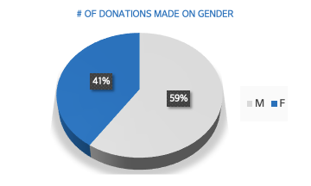

Query:

SELECT DONOR_GENDER,COUNT(DONOR_GENDER) AS DONATIONS_PER_GENDER

FROM DONOR

GROUP BY DONOR_GENDER;

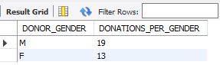

Number of donations made in various cities:

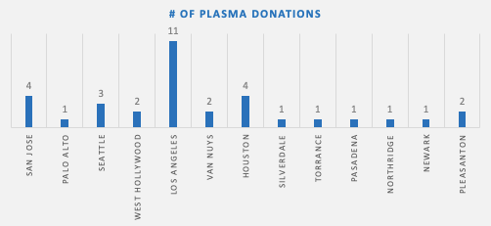

Query:

select b.pbank_city, count(donation_id)

from donation a, plasma_bank b

where a.pbank_id = b.pbank_id

group by b.pbank_city;

Number of COVID-19 Patients in each city:

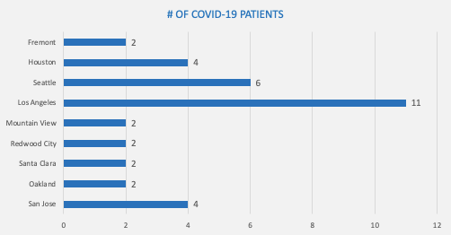

Query:

select hospital_city, count(patient_id)

from hospital a, patient b

where a.hospital_id = b.hospital_id

group by hospital_city;

### DATABASE SECURITY



Controlling Database Access : We will be restricting physical and remote access. We will monitor and remove inactive users; password management would be essential.

Managing Database User Accounts :

Each user can be a part of the following four roles that are created for PDMS.

* + pdms_read
  + pdms_write
  + pdms_hospital
  + pdms_plasmabank
    - There will be two major secure roles – pdms_hospital and pdms_plasmabank who will be granted with limited system privileges as required.
    - Hospital user will not have written access to plasma bank related tables and will not be able to access donor personal information.
    - Similarly, plasma bank user will not have access to patient’s personal information and will only have read permissions on Hospital tables.

Following are few examples of the roles that were created:

CREATE ROLE 'pdms_read', 'pdms_write’, ‘pdms_hospital’, ‘pdms_plasmabank’;

GRANT SELECT ON pdms.* TO 'pdms_read';

GRANT ALL ON 'pdms.* TO ‘pdms_write’;

Plasma bank users were granted privileges to select, insert, update, and delete records from the Plasma bank related tables

Example:

GRANT INSERT, UPDATE, DELETE ON pdms.PLASMA_BANK TO 'pdms_plasmabank’;

Hospital users can be granted privileges to select, insert, update, and delete records from the Hospital related tables

GRANT INSERT, UPDATE, DELETE ON pdms.HOSPITAL TO 'pdms_hospital’;

Roles can be granted/revoked/viewed for multiple users/groups using GRANT keyword.

Example:

GRANT 'pdms_read' TO 'read_user1'@'localhost', 'read_user2'@'localhost';

REVOKE INSERT, UPDATE, DELETE ON pdms.* FROM 'pdms_write’;

SHOW GRANTS FOR 'dev1'@'localhost';

A new user can be created by using CREATE USER command and assigned to the right role by using GRANT command.

Example:

CREATE USER new_user1@localhost IDENTIFIED BY 'Secure1287';

To assign roles to the above user, we used the following GRANT statement

GRANT ‘pdms_hospital’ TO new_user1@localhost;

•MySQL Enterprise Firewall

This will be used to block database attacks such as an SQL Injection and will guard against cyber security threats by providing real-time protection against database specific attacks

### DATA LOAD FILE



### References:

<https://www.bloodassurance.org/about-plasma-donation>

<https://www.mysql.com/products/enterprise/firewall.html>

<https://www.mysqltutorial.org/mysql-roles/>

<https://dev.mysql.com/doc/refman/8.0/en/security.html>

<https://www.fda.gov/media/141479/download#:~:text=The%20blood%20from%20people%20who,causes%20COVID%2D19>.